What Becomes of The Broken Hearted?

**Inside Diego's Heart you, as his anxiety, are trying to process his past relationship either through using violence or patience to soothe his aggrevated emotions.**

**Classification:**

-Genre: narratively explorable escape room

-Platform: PC

-Target Group: Mature audience

**Gameplay Summary:**

Project Heart’s gameplay can be divided into two sections

1. You escape the section of the heart by completing or destroying puzzles
2. You comfort or murder the emotions of the heart

**Narrative Summary:**

Anxiety is sent to the broken heart of Diego, a man whose heart is broken after a breakup with their partner. The heart has been broken into 3 sections, all governed by one negative emotion each: Anger, Fear, and Sadness. Anxiety’s task is to subdue these emotions by any means they choose.

**Unique Selling points:**

- It is the player’s choice how they want to experience the story.

- Unique topic to explore

**Rough Production Plan:**

The plan is to bring as many sections of the heart as we can (optimally 3) to a playable state until the Intermediate presentation. Those sections will then be polished for the final presentation. The aim is to at least get the very first Level to a polished result.

**TEAM PROJECT HEART**

*Alba Josefin Pläp Golfe – Lead and Character Artist | *alba.plaep@gmx.de*

*Maria Lobanova – Environmental Artist | *maroosyalmk@gmail.com*

*Ignacio Di Paola – Writer and Designer | [ignaciodipaola@hotmail.com](mailto:ignaciodipaola@hotmail.com)

*Frederyk Wilhelm Sperling – Programmer, Lighting Artist, and Sound Designer | [*mail@frederyk.de*](mailto:mail@frederyk.de)

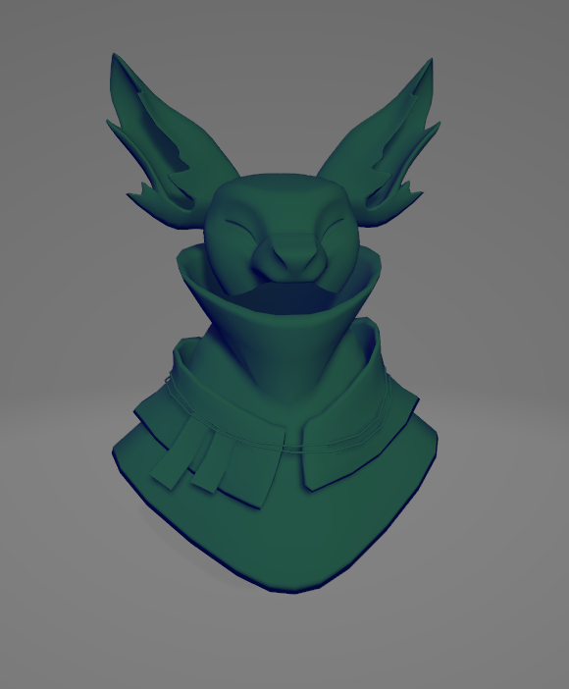

***Main Character | Anxiety | Fox****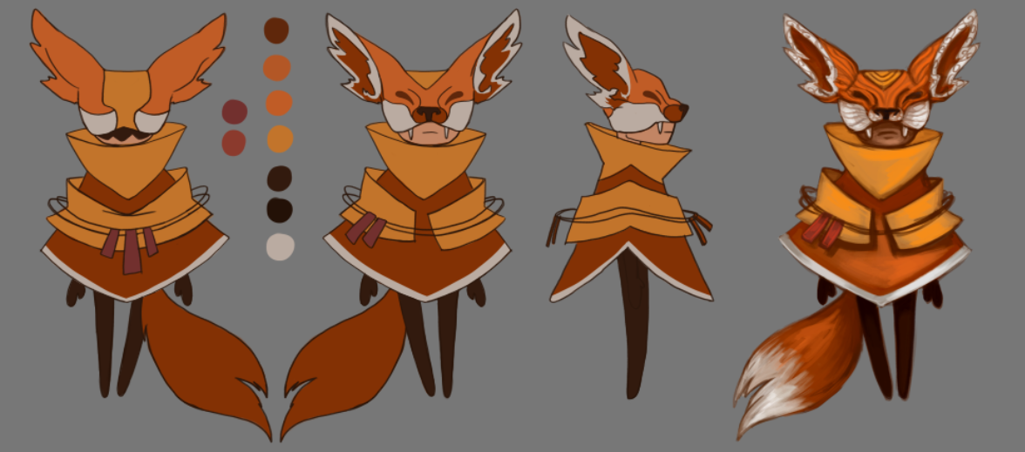*

***First Room | Anger | Aries***

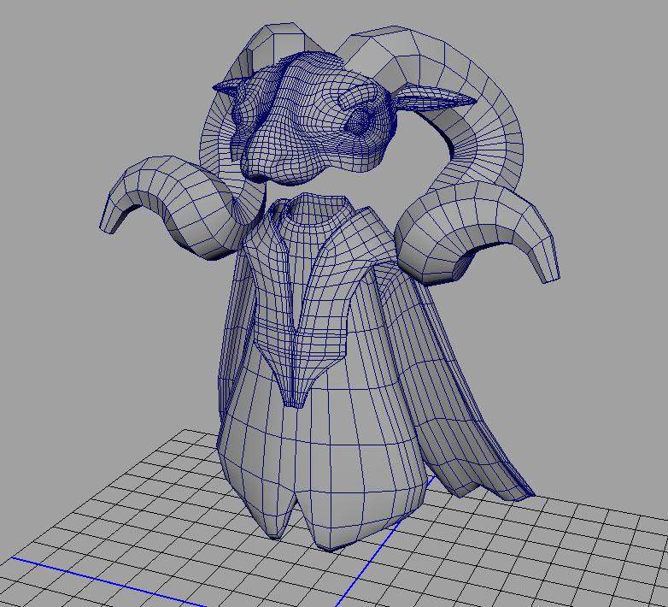

***Second Level | Fear | Rabbit***

*

